**DAILY ONLINE ACTIVITIES SUMMARY**

|  |  |  |  |  |  |  |  |  |
| --- | --- | --- | --- | --- | --- | --- | --- | --- |
| **Date:** | **02/06/20** | | | | | **Name:** | **Gulam Rabbani** | |
| **Sem & Sec** | **4th Sem “B” Section** | | | | | **USN:** | **4AL18CS099** | |
| **Online Test Summary** | | | | | | | | |
| **Subject** | | **Nil** | | | | | | |
| **Max. Marks** | | **Nil** | | **Score** | | | **Nil** | |
| **Certification Course Summary** | | | | | | | | |
| **Course** | [HTML and CSS for Beginners - Build a Website & Launch ONLINE](https://www.udemy.com/course/html-and-css-for-beginners-crash-course-learn-fast-easy/) | | | | | | | |
| **Certificate Provider** | | | **Udemy** | | **Duration** | | | **6:00:00** |
| **Coding Challenges** | | | | | | | | |
| **Problem Statement: 1 C program and 2 Java programs** | | | | | | | | |
| **Status: Executed** | | | | | | | | |
| **Uploaded the report in GitHub** | | | | | **Yes** | | | |
| **If yes Repository name** | | | | | **https://github.com/alvas-education-foundation/gulam_rabbani/tree/master/daily_progress** | | | |
| **Uploaded the report in slack** | | | | | **Yes** | | | |

Online Test Details: (Attach the snapshot and briefly write the report for the same)

No examination done today.

Certification Course Details: (Attach the snapshot and briefly write the report for the same)

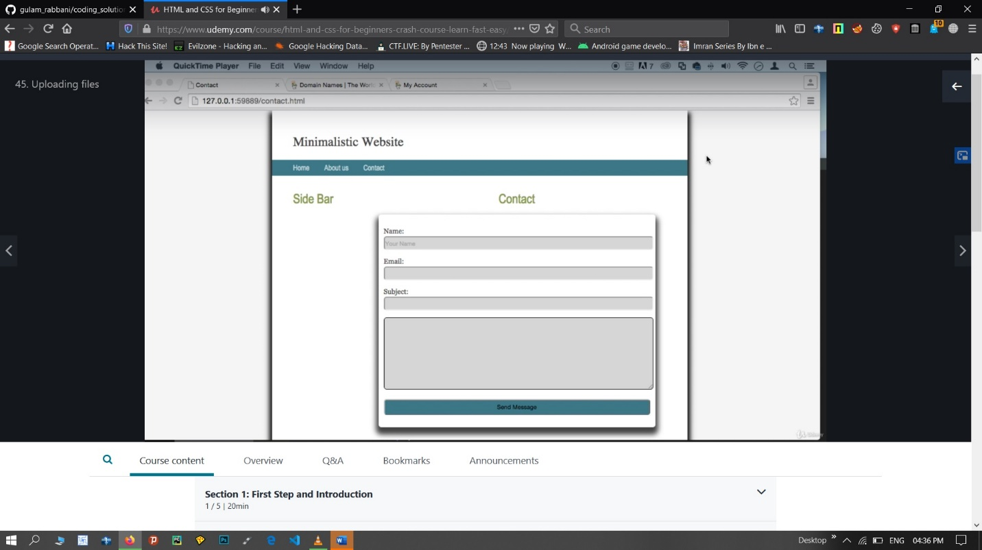

**What you’ll learn**

* You will Learn HTML
* You will learn CSS
* You will get a certification after the course that you can print
* You will get the skills you need to make websites

**Are there any course requirements or prerequisites?**

* Web Browser

**Who this course is for:**

* Total beginners
* Any person wishing to learn coding
* Any person that want to edit their website
* Any person looking for a second income online
* Any Student looking for quick way to learn HTML & CSS should take this course

Coding Challenges Details: (Attach the snapshot and briefly write the report for the same) 